Mrs. Egan’s 5th Grade

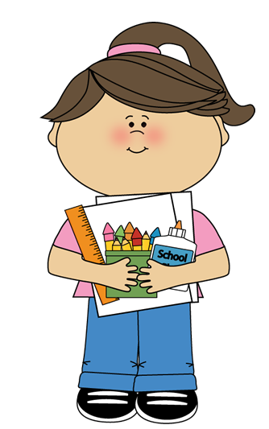2022/2023 Supply List 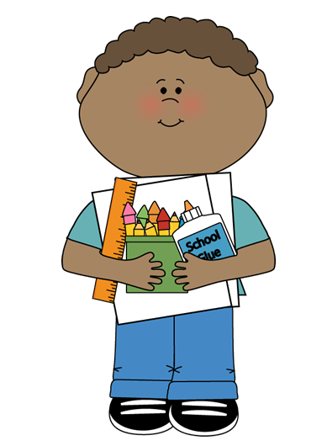

 1 notebook of your choice (for a Writer’s Notebook)

 3 marble composition books

 1 green plastic two-pocket folder

*Any plastic folders can work, if you can’t find a specific color*

 1 orange plastic two-pocket folder

 1 yellow plastic two-pocket folder

 1 red plastic two-pocket folder

 1 **black** plastic two-pocket folder

 1 storage bag/bin/box for supplies such as pencils, highlighter, scissors, glue stick)

 scissors

 water bottle and snack DAILY

*Please label EVERYTHING with your child’s first name*

 **Last name initial A-M: One bottle of liquid (or foam) hand soap

 ** Last name initial N-Z: One box of tissues

 Clearly marked earphones to be used daily

***Please bring them in a gallon-sized Ziploc bag labeled with name***